|  |
| --- |
| **SCSR2043 OPERATING SYSTEMS**  **Lab 3**  **[20 Marks]** |

|  |  |  |  |  |  |  |
| --- | --- | --- | --- | --- | --- | --- |
| Name | : | G A RUBAYAT HYDER |  |  |  | Marks |
| Student ID | : | A17CS5335 |  |  |  |  |
| Section | : | 02 |  |  |  |  |

**Instruction**: Please answer all of the following questions. Whenever the 🖑 symbol appears, please raise your hand to call your instructor, he/she will verify your results by putting his / her initial next to the symbol.

1. Type the following commands using a text editor and save it as a *yourname*.sh (Example: ahmad.sh).

echo “Hello world” > helloworld.jar

mkdir cars; mkdir dates; mkdir fruits drinks

cd cars; echo “Honda Accord” > accord.c

cp accord.c civic.c; echo proton > proton.c; cd ../dates;

date > dateoftheday

cat dateoftheday > appointment

cd ../fruits; echo apple > apple.txt; cat apple.txt > orange.txt

cd drinks; cp ../cars/*.* .; cp ../fruits/*.* .;

cp ../*.jar .

* 1. Execute the script and draw a tree structure that contains created directories and files. The parent node of the directory begin with **$HOME** directory. [4 marks]

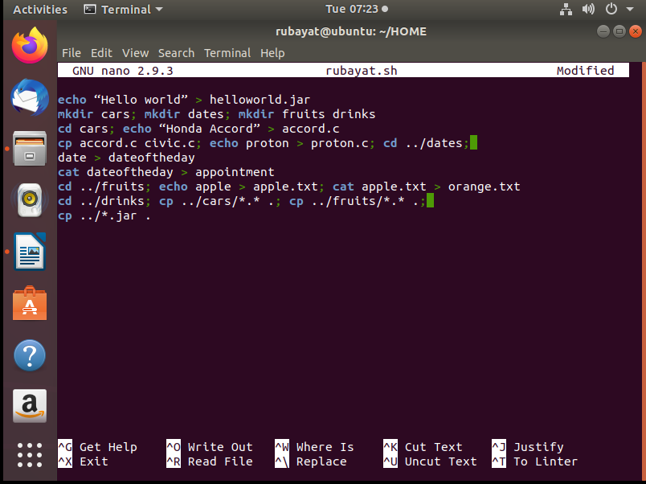

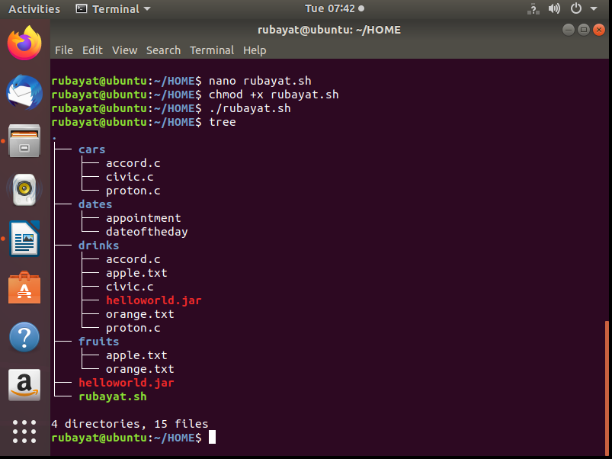

🖑

🖑

* 1. Write an interactive bash script that will read a type of file extension, display all those files, and count the number of files. To validate your script, display c program files, and enter “c” as the input to the bash script. [4 marks]

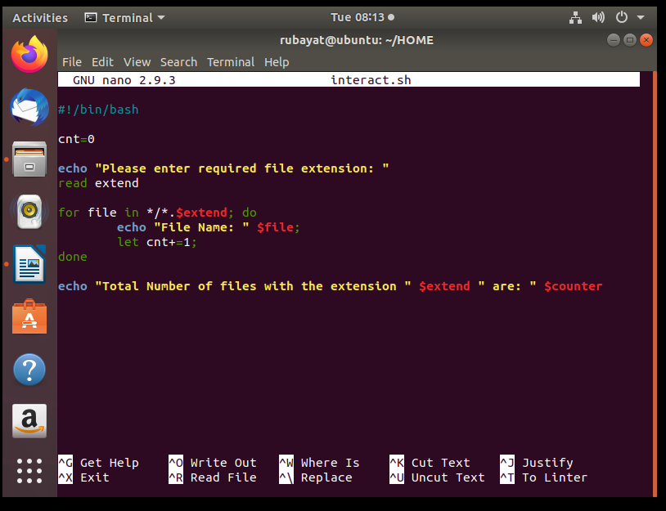

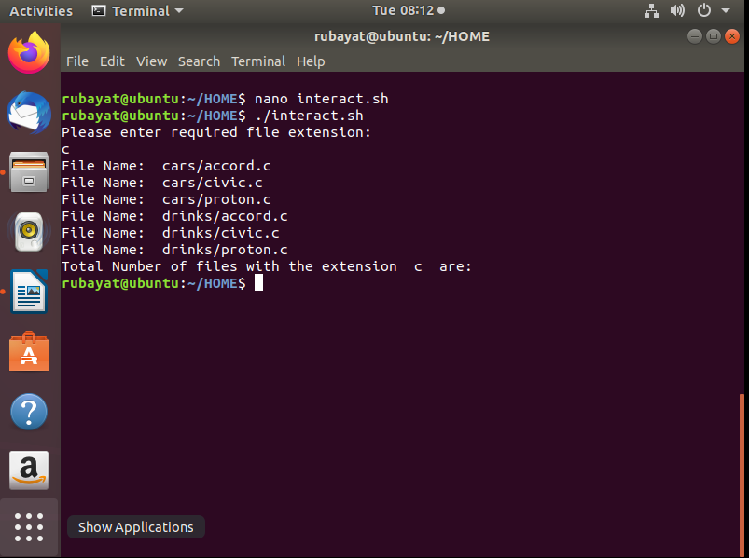

🖑

1. The following Figure 1 illustrates a tree structure of some directories and files.

- operating_systems

- software_engineering

- data_communication

- Linux_operating_systems

- Best_of_software_engineering

- dean

- deputy_dean

- **Project_Manager**

**Directory**

**Text Files**

Figure 1

* 1. Write a bash script (called myname2a.sh) that will produce directories and files as in Figure 1. Each text files contain its filename without the underscore character**.** For example:text file Project_Manager contains Project Manager). [4 marks]

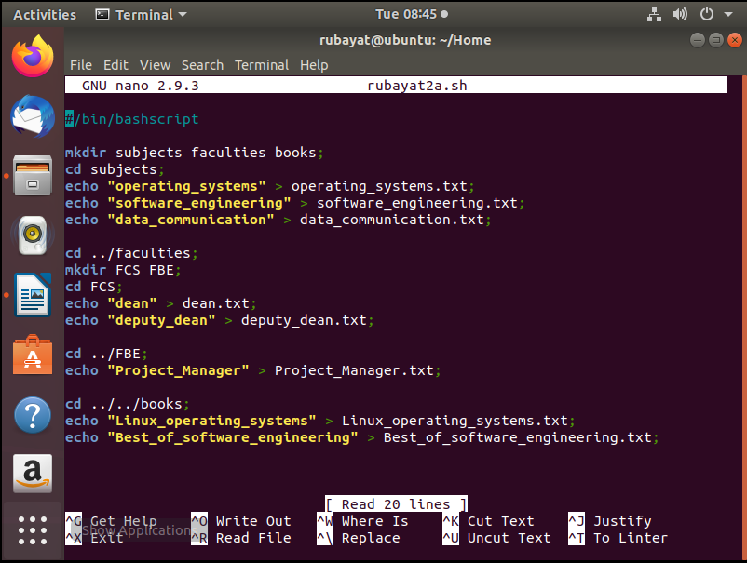

🖑

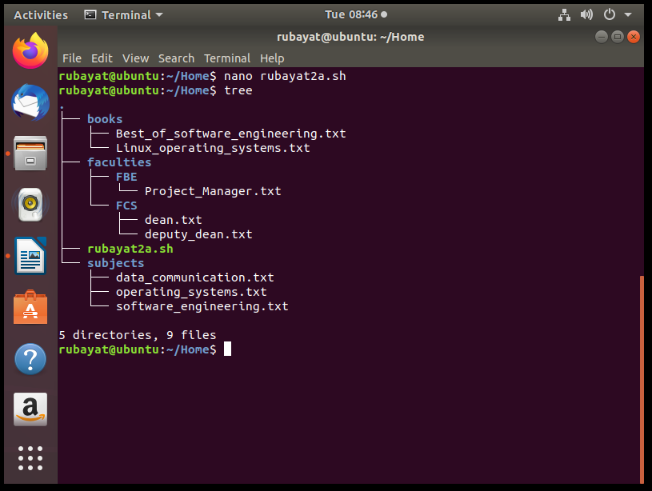

* 1. Complete the following table by writing the access control of directories or files that were produced. Given is the access control for directory called book. [2 marks]

|  |  |
| --- | --- |
| Directory/File | Access Control |
| books | drwxrwxr-x |
| subjects | drwxr-xr-x |
| Best_of_software_engineering | -rwxr-xr-x |
| FCS | drwxr-xr-x  🖑 |
| project_manager | -rwxr-xr-x |

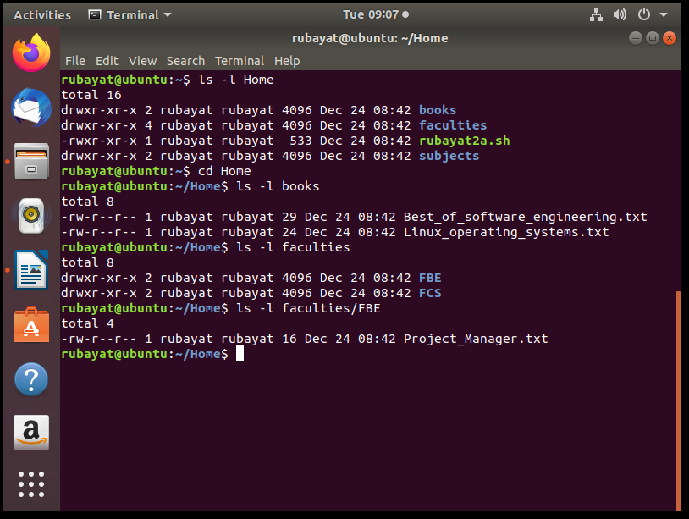

* 1. Write another bash script (called myname2c.sh) that will change the access control of the directories and files based on the following information: [4 marks]

|  |  |  |  |  |  |  |  |  |  |
| --- | --- | --- | --- | --- | --- | --- | --- | --- | --- |
| Directory/File | Users | | | | | | | | |
| Owner | | | Group | | | Public | | |
| subjects |  |  |  |  | x | x |  | x | x |
| Best_of_software_engineering |  | x |  | x |  | x | x | x | x |
| FCS |  |  | x | x | x | x |  |  |  |
| project_manager | x | x | x | x |  |  | x | x |  |

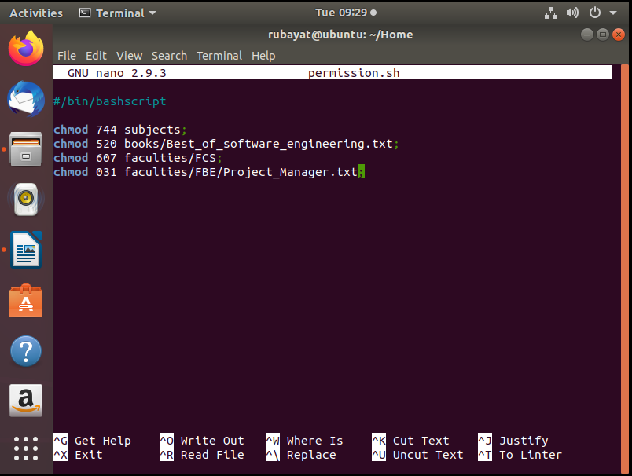

🖑

* 1. Complete the following table by writing the access control for each directory or file after executing the bash script in question 2(c)). [2 marks]

|  |  |
| --- | --- |
| Directory/File | Access Control |
| subjects | drwxr--r-- |
| Best_of_software_engineering | -r-x-w---- |
| FCS | drw----rwx |
| project_manager | -----wx--x |

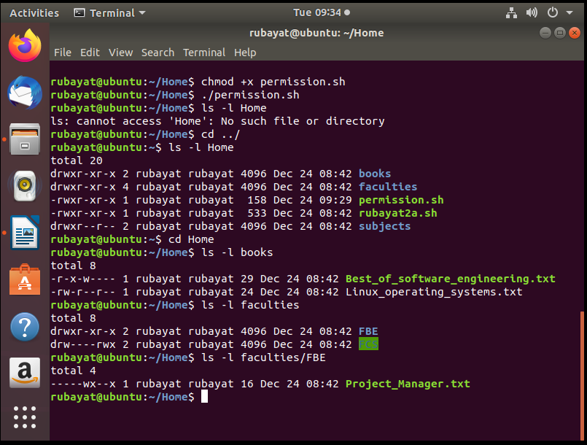

*End of Lab 3*

*\*\*\* All the Best for Final Exam \*\*\**